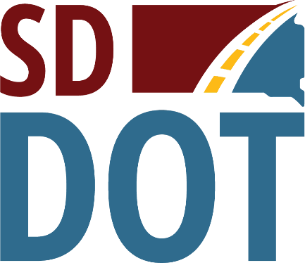 | South Dakota  Department of  Transportation

Open House/Public Meeting for
Shoulder Widening Project on
U.S. Highway 18
(James River to U.S. Highway 81)
Thursday, March 24, 2022
6 p.m.
Hutchinson County Courthouse
201 West Mentor Street
Olivet, SD 57052
Public is Encouraged to Attend
Public Meeting Information @
https://dot.sd.gov/projects-studies/projects/public-meetings
(Yankton Area)

